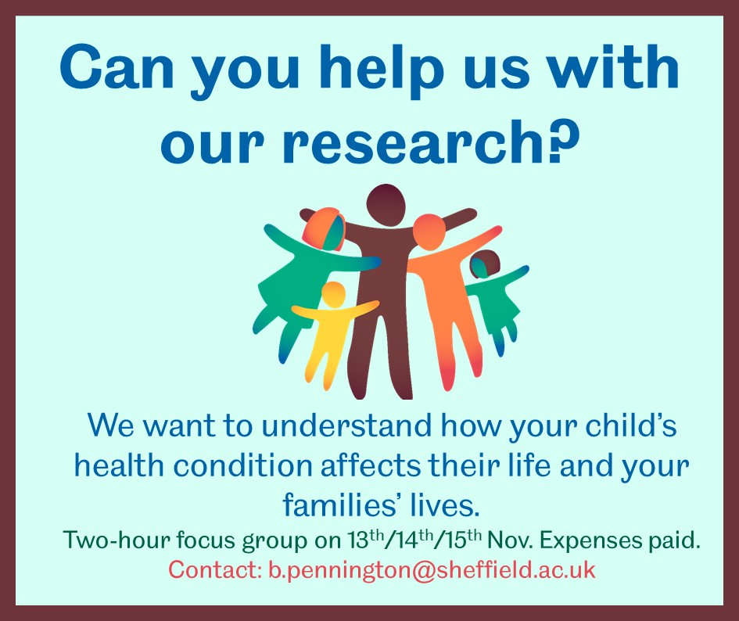
I am researching how children’s health conditions affect their and their families’ lives. I am organising a 2-hour focus group on 13th, 14th or 15th November in Sheffield, to hear from parents and carers how their child’s health condition affects both the child’s life and the family’s life. The children can be of any age (newborn up to 18 years old) with any health condition (for example, asthma, autism spectrum disorder, cystic fibrosis, epilepsy, cancer, or multiple health conditions).
You do not need to have any specific skills or experience.
Your input will help to make sure that my research considers all of the ways that a child’s health condition affects their life and the family’s life. My research project is about how funders like the NHS consider the effects of children’s health conditions when deciding whether to pay for new treatments/services for children.
At the focus group, I will provide an introduction to the research project and explain what funders currently consider when deciding whether to pay for new treatments/services for children. I will ask for your opinions on what you think funders should consider, based on your experience of caring for a child with a health condition. I will also ask you to read a one-page summary of the project, and provide feedback. The focus group will involve six parents or carers.
If you would like to be involved and are available for at least 2 hours on one of 13th, 14th or 15th November, please email me. It will be helpful if you can tell me which dates and times you are available, and which health condition(s) the child you care for has.

