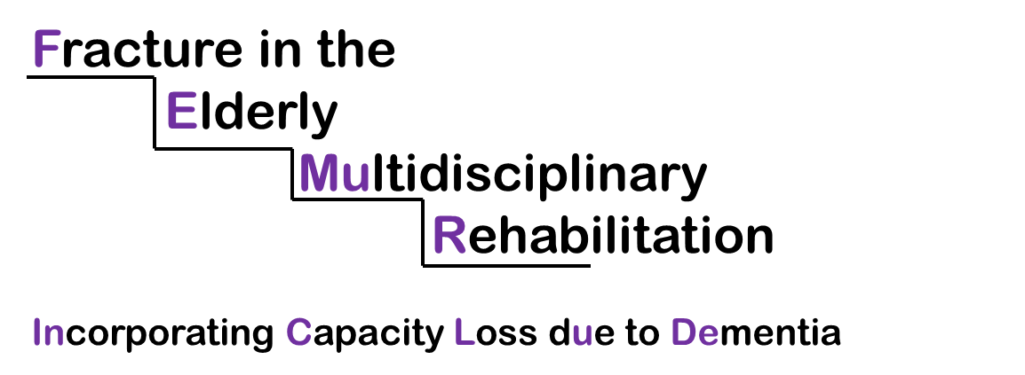

Rehabilitation after hip fracture in people with dementia
Carers can you help?
Do you have experience of looking after a family member or friend with dementia who has fallen and broken their hip? Would you like to use your experience to help shape a research project with the University of Liverpool?
Falling and breaking your hip is a major life event and many people struggle to get back to normal afterwards. This is particularly difficult for people with dementia, and we want to improve how rehabilitation is delivered to this group. So far, we have developed a workbook and goal-setting diary to enhance rehabilitation. We now want to adapt these for use by people with dementia and their carers, along with other dementia-friendly materials. We will then test these in a research study in preparation for a large clinical trial.
When a research study like this is designed, the team first write a research application and then apply for funding. A number of people get involved in shaping and designing the study when we write this application and some of this team become ‘co-applicants’ on the study. If a research team are successful in their application for research funding, the co-applicants remain involved with the study for its duration helping to guide and oversee the study. We recognise that research studies benefit from the experience of people affected by the condition, so we want to include a carer from the north west of England as a co-applicant on our study. If our team were awarded funding, your role would be as a public member of the team running this study. The study would last for 30 months and members of the team would be expected to attend monthly meetings (anticipated to last approximately one hour each) and to contribute to email discussions between meetings. Meetings may be face to face in Liverpool or by Freephone teleconference. In addition, in the first 6 months during the study design stage, you will be supported to lead a small group of carer representatives who will help to adapt the workbook and diary, and develop other dementia-friendly materials. This would mean taking part in up to four meetings (face-to-face or teleconferences using a Freephone number), usually lasting one hour with e-mail discussions in between.
You will be offered payment for your time, travel expenses and any additional costs of a professional carer looking after your relative whilst you attend the meetings. You will be supported in your role by the study team and a Patient and Public Involvement Co-ordinator.

Roles and responsibilities of co-applicants
What is a co-applicant?
A number of people get involved in shaping and designing the study when writing the research application to apply for research funding. Some of this team become co-applicants on the study. If the research funding application is successful, the co-applicants remain involved with the study for its duration, helping to guide and oversee it, and are responsible for its successful delivery. All of the co-applicants have a collective responsibility for the quality and integrity of the study, and to ensure that it is run safely.
As a co-applicants on the research team you will be required to:
- Discuss the study proposal with the chief investigator and provide the patient and public perspective on all relevant aspects of the study for the first stage outline application.
- Attend a study development group meeting if the proposal goes to the full application second stage
- Take an active role in the study management group meetings (if our proposal is funded).
- Prepare for meetings by reading papers that we send before the meeting.
- Raise questions and contribute your views and perspective to meetings and email conversations
- Be happy to work with the rest of the group according to our ‘ways of working’ document, (this document outlines how members of the group contribute, including listening to others and collaborative working).
- With guidance from the team, review and comment on the research study proposal and protocol.
- With the help of the research team, lead and support a small group of carers who are contributing to the adaptation of the workbook and diary and the development of other dementia friendly materials.

Frequently Asked Questions
Q1. What is the aim of the research?
The aim of the research is to help people with dementia to rehabilitate better after they have fallen and fractured their hip. In order to do this we will adapt a workbook and goal-setting diary from another trial of an enhanced rehabilitation intervention. We will then test these resources in a research study to see if they are suitable for a large clinical trial.
Q2. How will public involvement help?
We recognise that research studies benefit from the experience of people affected by the condition, so we want to include a carer from the north west of England as a co-applicant on our study. The public perspective will be invaluable throughout the study in many ways, including the information given to participants, the logistics of the study design, and the best ways to disseminate information about the study at the end. Examples of how the public help by getting involved in research can be found here: http://www.healthtalk.org/peoples-experiences/improving-health-care/patient-and-public-involvement-research/what-patient-and-public-involvement-and-why-it-important.
In addition, we wish to adapt an existing workbook and goal-setting diary for use by people with dementia together with their carers. We also wish to develop additional dementia-friendly materials such as cue cards and verbal prompts. We need help to ensure that all of these are sensible and likely to make a difference.
Q3. What are the benefits of being a public contributor in the study?
You will be part of a research team that is developing the research proposal. If the project is funded you will help oversee the research project. The experience of patient involvement in research, with the support of other members of the research team, can help you develop an understanding of the research process and possibly learn new information about dementia and falls.
Q4. What are the responsibilities of a co-applicant?
A public co-applicant is involved in the early stages of thinking about the research question and contributing to the research proposal. They may attend all the meetings of the Study Management Group. . They will provide perspectives on the research design, delivery and dissemination and will be encouraged to ask questions if they do not understand discussions. In between these meetings they will interact with the Chief Investigator, the study co-ordinator and other members of the study team by email. We will encourage our public co-applicants to feedback about their involvement to ensure that they are appropriately supported in their role. They will also have contact with other patient or public representatives who can share their personal experiences with them. On some occasions, it may be helpful for the public co-applicant to carry issues from the research steering group into this wider group for discussion and then carry the views of the group back into the steering group. The public co-applicant will be involved throughout the life of the project.
Q5. Who can get involved?
We wish to involve a member of the public with experience in caring for someone with dementia who has fallen and fractured their hip. The research team is based in the University of Liverpool, so we would like to involve someone who lives in North West England. We want to involve someone who is able to attend meetings (either face to face or by teleconference) and who would be happy to help our team in supporting other carers who get involved in the project by developing our resources and materials.
Q6. What would I need to do?
Initially our chief investigator Nefyn Williams will meet with you to explain more about the trial and to answer any questions that you have about your role. He will then seek your views and perspectives on our study proposal from a carer perspective. If the project is funded, you will attend the monthly study management group meetings (either face to face or by teleconference). We anticipate that the meetings will last for approximately one hour each. All members of these groups prepare for the meetings by reading the papers that we send. During the meetings we encourage you to contribute your views and ask any questions you have. In particular, to comment on the trial arrangements from the participants’ point of view. With support, you will be asked to review and comment on the research study proposal and protocol. There will also be a small group of carers who will help to adapt the workbook and diary and develop other dementia friendly materials for use in the study. With the help of the research team, we will invite you to lead and support this group. Again with support, you will also review and comment on the final report and publications from the project.
Q7. How will I be supported to undertake my duties?
The chief investigator, study manager and other members of the research team will support you in your role. They will familiarise you with the project when you start and will be available to discuss the project by telephone or e-mail. The trials unit also has a patient and public involvement co-ordinator (Heather Bagley), who is available, as required, to support you in this role.
Q8. How much time would be involved in this role and how long would I need to be involved for?
Activity | Time involved
Discuss the study proposal with the chief investigator and provide the patient and public perspective on all relevant aspects of the study for the first stage outline application | 1 hour preparation reading the draft proposal and 1 hour discussion face to face or by telephone in December 2018
Attend a study development group meeting if the proposal goes to the full application second stage | 1 hour preparation reading the draft proposal and 1 hour meeting (face to face or by telephone) in Spring 2019
Attend the study management meetings | 1 hour every month for 30 months from July 2019
Read and prepare for the meetings | 1 hour every month for 30 months
Attend the patient group meetings to help adapt the workbook and goal-setting diary and to develop other dementia-friendly materials | 2 hours x 4 meetings
Read and comment on the final report and publications | 12 hours

Q9. What are the dates for this study?
We wish to involve someone as soon as possible. We need to submit our first stage outline research proposal in early January 2019. If successful, we will be invited to submit a second stage full application in the Spring 2019. If the research proposal is funded, we hope to adapt the workbook and diary and develop other dementia-friendly materials from July 2019 during the pre-award phase. If funded, the research project proper will start in January 2020 and will end in December 2021.
Q10. Will I receive payment & expenses for my involvement?
Yes, the research project will have funds for your time, travel expenses and also to pay for a professional carer for your relative or friend with dementia whilst you are attending meetings. You will be offered payment of £50 for each meeting to pay for your time spent preparing for the meetings (approximately one hour) and for attending the meeting (lasting approximately one hour). The same hourly rate of £25 will be paid for time spent reading and commenting on the final report and publications, and supporting the patient panels.
It is important to note that these payments may have implications if you are in receipt of benefits, and if you pay income tax. More information on this is available from http://www.invo.org.uk/resource-centre/benefits-advice-service/
Q11. What skills do I need to have for this role?
We want to involve a member of the public with experience in caring for someone with dementia who has fallen and fractured their hip and who lives in north west England. Someone who is willing to attend meetings, undertake the necessary preparatory work and be an enthusiastic member of our research team. Also someone who, with support, is willing to lead and support other carers when adapting the workbook and diary, and developing dementia friendly materials. Previous experience of patient and public involvement in research, and other relevant experience such as patient participation groups, advocacy roles, and team working are desirable but not essential.
Q12. I’m interested, what should I do now?
Step 1 – We are delighted that you are interested! We would now like to invite you to fill in an expression of interest form and send it back to me, Nefyn Williams, Professor in Primary Care, Nefyn.williams@liverpool.ac.uk by 14 December 2018.
Step 2 – Professor Nefyn H Williams and Mr Ben Hardwick will read and consider all expressions of interest.
Step 3 – We will let you know by 17 December 2018 whether or not we have chosen you to be our co-applicant.
Q12. Who do I contact for more information?
Please contact Professor Nefyn H Williams, Professor in Primary Care, Nefyn.williams@liverpool.ac.uk for further information.

Expression of Interest Form

Please complete the form below and return to the FEMuR-InCLuDe chief investigator Nefyn Williams by Friday 14th December 2018.

Name
Email address
Telephone number
Preferred method of contact to discuss this expression of interest | Please tick one option:  Email  Phone  Either

Question | Comments
It would help us to know more about the lived experience that you could bring to the study. Have you cared for someone with dementia who has fallen and broken their hip? | Please tick one option:  Yes  No
Do you live in the north west of England? | Please tick one option:  Yes  No
We will be holding meetings once a month between July 2019 and December 2021. Would you be able to attend meetings (either face to face or by teleconference), lasting approximately one hour, with approximately one hour’s preparation beforehand? | Please tick one option:  Yes  No
Would you be able to provide comments on information we send to you via e-mail or post? | Please tick one option:  Yes  No
With the help of other members of the research team, would you be willing to lead and support other carers when adapting the workbook and diary, and developing dementia friendly materials. | Please tick one option:  Yes  No
Have you ever done patient and public involvement in research before? | Please tick one option:  Yes  No  If yes, please provide a brief summary below (up to 100 words):
Do you have other relevant experience such as patient participation groups, advocacy roles, or working as a member of a team? | Please tick one option:  Yes  No  If yes, please provide a brief summary below (up to 100 words):
Do you have a basic understanding of randomised controlled trials? | Please tick one option:  Yes  No

Please return your completed form to:

Email address: nefyn.williams@liverpool.ac.uk

Postal address: Professor Nefyn H Williams
Department of Health Services Research
University of Liverpool
Waterhouse Building Block B 1st Floor
1-5 Brownlow Street
Liverpool
L69 3GL

