SPRING EDITION 1

PATIENT CENTRIC DRUG DESIGN TO IMPROVE ADHERENCE AND ACCEPTANCE IN OLDER PEOPLE

People are living longer following improvements in healthcare and lifestyle. Older people tend to take more medicines. Remembering to take the medication can be difficult, partly because older people are taking lots of medicines. The form of the medicine (e.g. the shape, size and colour) can have a big impact on whether or not the person takes the medication as recommended by the doctor.

What do we need to think about?
- Use of lots of medications
- Conditions related to age
- The need for a carer
- The ability to tell different pills apart
- Difficulties swallowing
“In all cases, the product should be designed to meet the patient’s needs…”

What are the aims of this study?
This study aims to improve the way older people are able to take their medication by improving the design of tablets and capsules. We will look at factors such as the shape, size and colour to help make these medicines as easy as possible to take.
How will we do this?
Step 1: Find out what has already been done- We are currently looking at all the research in this area to find out exactly what has been done so far. We will then use this to identify the gaps that future research should address.

Step 2: Talk to patients, carers and health and social care professionals to understand what factors are most important to them- how can we make these medicines as easy as possible to take?

Step 3: Use the information given to us to design a product which is suitable for an older person to take and confirm this again with older people, their carers and health and social care professionals.

SPRING EDITION 1
Who can help?

Designing a final product which takes into account the characteristics that older people and their carers prefer will need to consider the views of everyone involved in their treatment:

- Older people aged 65 or over and taking any number of tablets or capsules
- Carers who provide care as a family member or friend of an older person who has to take tablets or capsules
- Healthcare professionals such as doctors, nurses or pharmacists who have experience working with older people who may have difficulties taking tablets or capsules
- Social care professionals who have experience working with older people who may have difficulties taking tablets or capsules

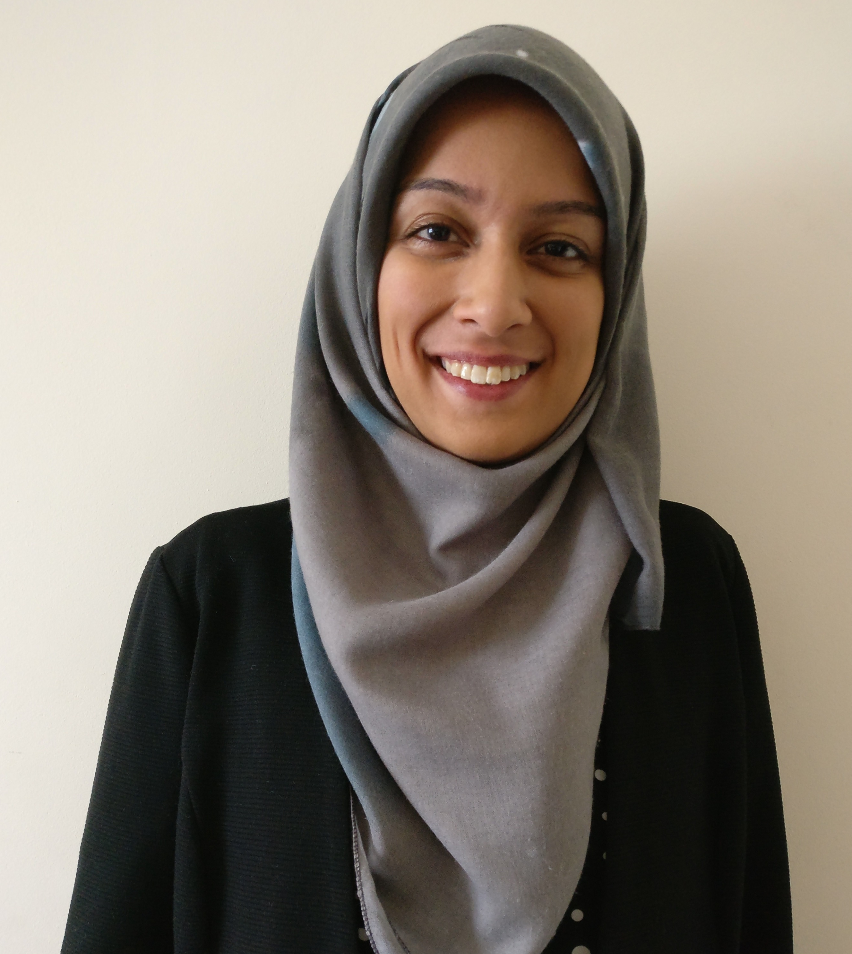
Introducing the Lead Researcher
The difference this project can make
By improving adherence and acceptance, we aim to reduce medicine wastage, reduce adverse events due to non-adherence and ultimately improve quality of life.

Why this project is important to me
The number of drugs on the market has increased, however their benefit depends on a suitable final drug formulation. Unless this issue is addressed, many resources are being wasted due to patient non-adherence.

Zakia Shariff, Pharmacist and PhD student
Before starting my PhD, I worked as a community pharmacist for four years. During this time, I encountered older patients on a regular basis who were struggling to take their medication due to factors such as the size and shape. From my experience, older patients are a diverse population with individual needs which I hope to explore further through this research.

WATCH THIS SPACE

If you would like to be involved or receive regular updates, please contact:

Zakia Shariff (Lead Researcher):
ramjeez1@aston.ac.uk
07905 875 111

