Role Description
UK-based Public Advisory Group for the Global Surgery Unit

Background
The NIHR Global Health Research Unit on Global Surgery (GSU) was formed in 2017 to grow a network of research hubs in low and middle income countries (LMICs). The aim is to support surgical health research as a major global health concern in these settings. The Unit is looking into ways to build surgical capacity and minimise post-surgery mortality rates in rural areas in LMICs. This is achieved by working collaboratively with global partners on prioritising and funding smaller scale country-specific pump priming studies on local surgical needs, as well as conducting international randomised controlled trials in surgery. Issues that are being addressed are surgical site infection and wound healing, safer surgical practices and capacity building in district hospitals.
Our current research hubs are located in Mexico, Ghana, Nigeria, Rwanda, South Africa, and India, with further Centres supporting recruitment to clinical trials in The Philippines, Zambia, Benin and Egypt.
The patients in these countries are at the heart of everything the Unit does, meaning we aim to deliver surgical research where areas of concern have been identified by local communities. Pump priming studies as well as our clinical trials have been designed in collaboration with our global surgeons to ensure relevance and importance of our studies and we are committed to involving patients throughout the entire process.

Responsibilities for the UK-based Public Advisory Group
As we take the Unit forward and expand our global reach, we are in need of a UK-based Public Advisory Group representing the countries we work with. Key responsibilities include:
- Identify priorities for our overarching patient and public involvement strategy in LMICs, feeding into outcomes that matter to local communities.
- Review and provide feedback on study design, e.g. protocols, feasibility of study, potential barriers to recruitment, how to involve local communities.
- Review and provide feedback on patient-facing materials for the clinical trials, e.g. patient information packs, focus group materials.
- Review and provide feedback on our patient facing websites.
- Design and review training materials for surgeons on how to involve local communities throughout the research cycle.

Figure 1: The UK-based Public Advisory Group within the Global Surgery Unit (GSU)
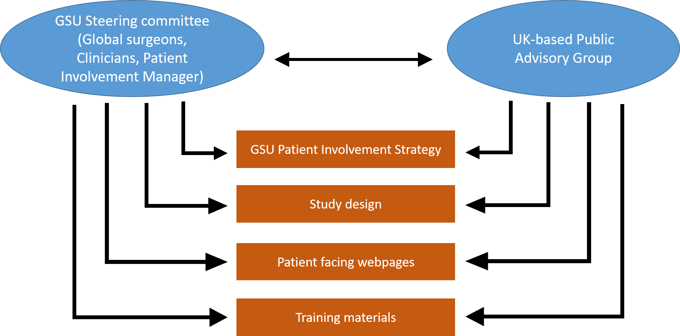

Ways of working
The group will meet every two months to discuss overarching matters. Individual members may also be contacted at other times to provide comments on country- or study-specific matters.
Members of the group will be asked to read papers and documents related to the meetings they are attending and prepare feedback and comments. They will be supported in doing so by the Patient Involvement Manager.
Requirements
- We are looking for individuals from Mexico, Ghana, Nigeria, Rwanda, South Africa, India, The Philippines, Zambia, Benin and Egypt, who have lived in one of these countries in the past 10 years. Or individuals (any nationality) who have lived in one of these countries for more than one year in the past five years.
- An interest in surgical care and knowledge of the healthcare system in one of the above mentioned countries is essential.
- Good written and spoken English.
- Good communication skills.
- Excellent team working skills.
- Ability to follow instructions and work autonomously.

Recruitment process
A short application form will be provided and the applicant’s skills will be matched to the outlined criteria. Shortlisted candidates may be invited to an informal interview at the University of Birmingham prior to being appointed the post.
Duration of appointment
We seek to appoint members of the group until April 2020 initially. The term can be extended, subject to funding.

Learning and support
Support for the role will be provided and tailored to individual needs and requirements. An induction programme will be provided.

Covering Expenses
By “covering expenses” we mean reimbursing the costs that are incurred by a member of the public while being involved in GSU related activities. All out of pocket expenses will be covered, e.g. travelling by car/bus. Refreshments will be provided at all meetings.
Payment
By “payments” we mean payment made to members of the public for their input of time, skills and expertise. Payments for members of this group are aligned to INVOLVE guidelines and will be offered at £20 per hour of each meeting, £75 for half a day and £125 for a full day. This payment would cover the member’s time and any other associated costs e.g. printing. Rates of payment for activities outside attendance at meetings (e.g. reviewing documents), will be communicated to members prior to involvement.
Payment will be made following submission of the claim form that will be provided.

Confidentiality and non-disclosure of information:
Confidentiality must be maintained in relation to any personal information and information related to personal health the member of this group gathers through personal and electronic contact with other members, or users of NHS and social care services. Any information related to GSU activities must be treated in confidence.

Contact:
For further information about patient and public involvement with the NIHR Global Health Research Unit on Global Surgery, or to submit your Expression of Interest form, please contact:
Karolin Kroese, GSU Patient & Public Involvement Manager
E: K.Kroese@bham.ac.uk
T: 01213718498
Expression of Interest
GSU Public Advisory Group Member
Personal Information
Surname or Family Name |  |  |  | Title (Mr, Ms, Dr, etc)
Other Names
Birth year
Place of Birth
Gender
Address
Tel  (Home) |  | Tel (Mobile)
Email address

Please tick the box which best describes you ()
Medical / Healthcare Professional
Academic/ Researcher/ Scientist
Student
Patient/ Carer
Member of the public with an interest in surgical research
Other (please specify)

Which country are you from/have you lived in for a substantial amount of time?
(Mexico, Ghana, Nigeria, Rwanda, South Africa, India, The Philippines, Zambia, Benin, Egypt)

When and for how long did you live in this country?
(YYYY-YYYY)

Tell us in no more than 500 words, why you would like to be part of our UK Public Advisory Group and what contribution you feel you can make to this role? Please outline your experience with the healthcare system in the country you have specified above and mention any surgical health-related expertise/knowledge, if any (This can also be based on experiences family and friends have had).

Other Information
Please list any other Public Involvement in Research groups or panels you are/have been previously engaged with:

Declaration
 | I confirm that the information provided on this form is correct and I understand that any miss-representation or omission may render me liable to dismissal from duties, if engaged. I understand that the information will be stored in manual and electronic files and is subject to the provisions of all current data protection regulations.
 | PLEASE NOTE: It is important that people receiving welfare benefits get personalised advice about their own individual circumstances before getting involved and accepting any payments for involvement with our research activities. Please see www.invo.org.uk/posttypepublication/payment-for-involvement for further information and guidance.
 | Signature |  | Date
On completion of this form, please send:
- By email to: K.Kroese@bham.ac.uk
- By post to: Karolin Kroese, 2nd Floor, Open Plan East, Institute of Translational Medicine, Heritage Building, Queen Elizabeth Hospital, Mindelsohn Way, Edgbaston, Birmingham B15 2GW
Please return the form by 23 August 2019

Privacy Notice
- University of Birmingham is the Data Controller and will process your personal information for the purposes of creating and updating your contact details and involvement in the GSU Public Advisory Group.
- Personal information you provide on this application form will only be used for contacting you about your application.
- Your personal information will not be shared with any other 3rd party or organisation unless you have consented for UoB to do so. Unless, there are exceptional circumstances, such as when the health or safety of others is at risk, where the law requires it or there is an overriding public interest to do so. Where there is cause to do this, the University will always do its best to notify you of this sharing.

Should you have any questions regarding this statement please contact the Patient and Public Involvement Manager using the details below:

Karolin Kroese
Patient and Public Involvement Manager
Open Plan East, 2nd Floor, Institute of Translational Medicine,
Heritage Building, Birmingham, B15 2TH
Tel: 01213718498
Email: K.Kroese@bham.ac.uk

