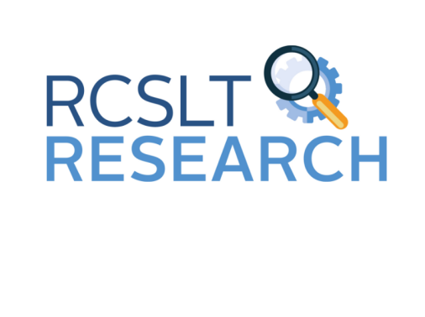

Research Priorities Project

Developmental Language Disorder



Royal College of Speech and Language Therapists



We are **investigators.**

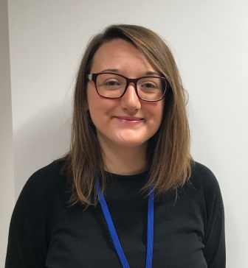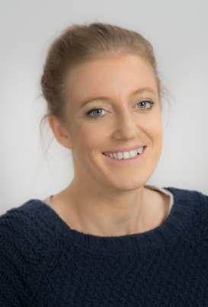

Amit Kulkarni Lauren Longhurst Katie Chadd



We want to find out about **Developmental Language Disorder (DLD).**



2 children in every class of 30 start school with DLD.

DLD is a life-long condition which can first be diagnosed in early childhood.



Children with DLD may have difficulties with...



Social interaction

Listening, attention, memory and language processing

Understanding vocabulary, questions and narratives

Using spoken language

The RCSLT has launched an exciting [project](https://www.rcslt.org/-/media/Project/RCSLT/research-priorities-piktochart-project-flyer-Dec16.pdf)  to determine the top priorities for new research in DLD.



**The Research Priorities Process:** 

1. We asked **different people**:

What are the most **important topics** in DLD **you want to find out more about?**

**Charities**

**Children with DLD**

**Parents and carers**





**Teachers**

**Speech and Language Therapists**



2. The topics were discussed and research priority areas suggested, in 2 multi-stakeholder workshops held in Spring 2019.

3. A long list of research priority areas were finalised.



**What’s next?**

4. The list was refined and put into an online card-sort activity. This allows clinicians and service users to select which topics they feel are a priority for research in DLD.





8. We will tell you the **final decision** on the **top ten most important things to find out about DLD.**





If you want to ask any more questions or tell us your thoughts you can **get in contact.**

Lauren Longhurst

[lauren.longhurst@rcslt.org](mailto:lauren.longhurst@rcslt.org)

0207 378 3029

