Increase in colonic PRopionate as a method of prEVENTing weight gain in young adults

Chief Investigator: Professor Gary Frost
Study Protocol Number: 18HH4903
IRAS ID: 229300

Participant Information Sheet

You are being invited to take part in a research study. Before you decide it is important for you to understand why the research is being done and what it will involve. Please take time to read the following information carefully and discuss it with others if you wish.
Part 1 tells you about the purpose of this study and what will happen if you take part. Part 2 gives you more detailed information about the conduct of the study. Ask us if there is anything that is not clear or if you would like more information. Take time to decide whether or not you would wish to take part. Thank you for reading this.

PART 1

What is the purpose of the study?

Overweight and obesity affects over 60% of the UK population. In adults, most weight gain occurs when people are in their 20s and 30s and causes many adults to become obese by the time they are middle-aged, leading to increased risk of developing diabetes, heart disease and cancer. There is increasing evidence that diet plays an important role in preventing obesity. The amount of fibre (found in edible plant foods such as cereals, fruits, vegetables, dried peas, nuts, lentils and grains) eaten in the diet has been linked to body weight. People who eat low amounts of dietary fibre are more likely to gain weight. Dietary fibre is the major food for the bacteria that live in our gut. We know that dietary fibre keeps the bacteria in our gut healthy. These bacteria break down dietary fibre to short chain fatty acids (smaller pieces of fibre) which can reduce appetite and body fat.

We have focused on one short chain fatty acid called Propionate because it appears to be the most powerful at reducing appetite. Propionate by itself would be broken down rapidly in the body so we have created a new food supplement called Inulin Propionate Ester (IPE) which is Propionate chemically bound to a fibre called Inulin. Inulin is a type of fibre normally found in garlic, Jerusalem artichoke, chicory and onion. The IPE simply delivers the Propionate to the right region of the gut where we think it is most effective.

This is a randomised controlled study to investigate the effects of IPE on prevention of weight gain in young adults aged 20-35 years at high risk of gaining weight, across a period of 12 months.
Who is involved in the study?
We are planning to study 270 participants in total, across two clinical research facilities - one in London, part of Imperial College Healthcare NHS Trust and one in Glasgow, part of NHS Research Scotland.

Why am I being invited?
You are being asked to take part in this study as you are aged between 20 to 35 years and have a Body Mass Index (BMI) of either 25-30kg/m² if you are non-South Asian, or 24-27kg/m² if you are of South Asian origin BMI is a value calculated from your height and weight, which estimates body fat. One or more of the following will also apply to you: you have gained 2kg or more over the past year, the level of physical activity you do is low, you eat less than two portions a day of fruit and vegetables, or you drink more than one sugary drink per day. You should also be on stable medication if you are taking any.

You are not suitable if:
- You have a diagnosed chronic disease; Type I and II diabetes, cancer, kidney failure, heart disease, organic acidaemia (propionic acidaemia, methyl malonic acidaemia)
- You have a gut condition including coeliac disease, inflammatory bowel disease (IBD) and irritable bowel syndrome (IBS)
- You have had previous bowel (intestine) reconstruction surgery
- You are pregnant or breastfeeding
- You have used antibiotics at any time in the past 3 months
- You are anaemic and have low Vitamin B12 levels in your blood
- You have anything else which upsets your gut such as diarrhoea/constipation in the last 2 weeks, abdominal cramping
- You are currently taking part in a weight loss programme or taking something to lose weight
- You have lost 3kg or more of weight, in the last 3 months
- Any other reason that the research doctor thinks may interfere with your taking part in the study

Do I have to take part?
It is entirely up to you whether or not to take part. If you do we will ask you to sign a consent form. You are free to withdraw at any time and you do not have to give a reason. A decision not to take part or to withdraw from the study at any time, will not affect the standard of care you receive or your legal rights.

Will I get paid for participating?
You will be paid £50 per study visit and there will be a total of 4 study visits, but there is also an initial visit to check if you are eligible to take part, which isn’t paid for. You are able to claim back travel expenses for all study visits and also the initial eligibility visit.

What is the study investigating?
As mentioned, we are investigating the effects of a dietary supplement called Inulin Propionate Ester (IPE), on prevention of weight gain in young adults aged 20-35 years at high risk of gaining weight, across a period of 12 months.

What will happen if I take part?
If you are eligible and still want to participate, you will be enrolled in the study for 12 months. You will first meet one of our researchers who will ask you some questions. You will then undergo a series of measurements and tests at various study visits described below.

Eligibility visit
You will be asked to complete a consent form before any study procedures are carried out. You will be given an IPAQ questionnaire to complete, this is a questionnaire which asks about your physical activity levels. You will have a standard full blood test (approx. 10mls) to check general health and if you are female you will also have a pregnancy test. If your blood test shows that you are anaemic then your blood sample will also be tested to check what your Vitamin B12 levels are. You will be asked about your medical history and any medications you are taking. You will also be asked several questions about your lifestyle, and have your height, weight, waist, hips, body composition (proportion of body fat) measured.

You will have your blood pressure measured, and something called an Electrocardiogram (ECG). This is a test which measures the rhythm of your heart to show whether or not it is working normally and this is the only visit it will be checked. The test involves attaching a number of small, sticky sensors called ‘electrodes’ to your arms, legs and chest which are connected by wires to a machine. The test only lasts a few minutes. Before the electrodes are attached, you'll need to remove your upper clothing, and your chest may need to be shaved or cleaned. Once the electrodes are in place, you will be offered a hospital gown to cover yourself if you wish.

If you meet all the study eligibility criteria, you will be asked to consider taking part in the trial. If you agree to take part, you will be given a food diary to complete for 7 days before your baseline visit (first study visit).

You will be asked to change into a pair of ‘scrubs’ to have your measurements taken

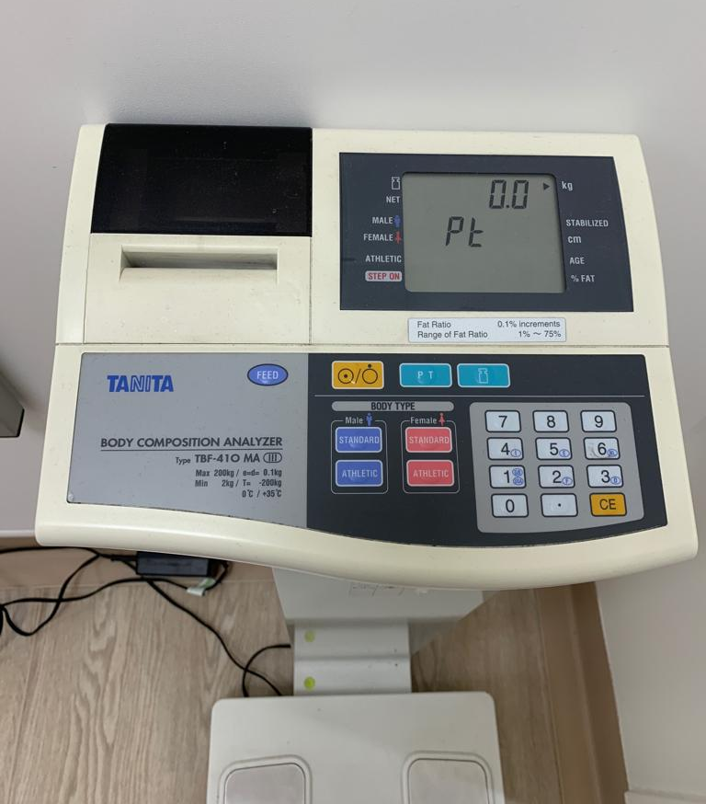

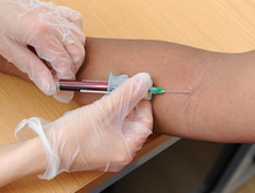

A standard blood test
We have special machines that you stand on, to measure your weight and body fat proportions.

Hip and waist measurements will be taken with a measuring tape

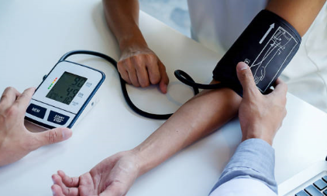
Blood pressure will be measured using a cuff wrapped around your upper arm, linked to a monitor.

For an ECG, you will lay on a bed and electrodes (sticky pads that detect your heart rhythm) will be put on your chest, and connected to a screen /printer which show the results.

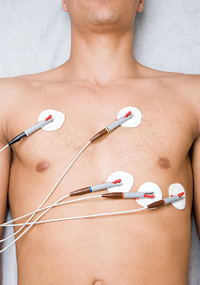

Baseline visit (first study visit)
You will have the same measurements that were done during your eligibility visit repeated again except for an ECG, and this time you will have a fasting blood test taken (2 tubes - approx. 10mls + 4mls) to measure your blood lipids (fat and cholesterol), glucose and insulin levels. A fasting blood test means you must not eat anything and can only drink water for 8 hours before your test.
Your 7 day food diary completed before this visit will also be collected.

We need to compare two different treatments. To find out which is better, we put people into two groups and give each group one of the two treatments. The results are compared to see if one is better. To try to make sure the groups are the same to start with, each participant is put into a group by chance (randomly).
You will be randomised to either the group taking the Inulin Propionate Ester (IPE) or the ‘control’ group taking Inulin (fibre) alone, for 12 months. These are all natural constituents of vegetables such as onions, chicory and Jerusalem artichokes.

You and your researcher will not know which food supplement you are taking, to avoid any bias.
You will be given a supply of supplement sachets to last until the next study visit and be asked to take one sachet daily. Each sachet contains 10 grams of supplement. This will just be in addition to your normal diet and is best taken with cold food or drink (i.e. sprinkled or mixed in). The supplement has very little or no taste, depending on how sensitive your taste is. You are not being asked to change your diet or lifestyle in any way. You will be given a food diary to complete for 7 days before your next study visit and you will be asked to keep and return all used and unused sachets of supplement at your next study visit.

2 months and 6 months visits
You will have a similar series of body measurements taken as the previous visits: weight, waist, hip, body composition and blood pressure. You will also be asked to complete the IPAQ questionnaire about your physical activities again, be asked for an update on lifestyle, medical history and any medications you have taken or stopped. If you are female you will have a pregnancy test. You will only have a fasting blood test taken to measure your blood lipid, glucose and insulin levels at the 6 month visit (not the 2 month visit).Your 7 day food diary completed before these visits will be collected and you will be given a food diary to complete for 7 days before your next study visit. Your unused and used sachets of food supplement will be collected and counted and you will be asked if you missed or forgot to take the supplement on any days, and why. A further supply of supplement will be given to you and once again you will be asked to keep and return all used and unused sachets of supplement at your next study visit. You will also be asked if you have had any medical events, symptoms or side effects since the last study visit and these will be recorded, even if they are not related to the study.

12 months visit
This is your final study visit. You will have the same body measurements taken as the previous visit and have all the same questions asked. . Your 7 day food diary completed before this visit and your unused and used sachets of food supplement will be collected. No further supply of food supplement will be given as you have now completed the study.

What happens to my blood samples?
Your blood samples and pregnancy test samples will be transferred to the local laboratories immediately for analysis, except for one tube from the fasting blood test, which will be stored and analysed at the end of the study. Any remainders of samples will be safely thrown away.
Your test results will be provided to the research team who can also tell you your results.

The results data will be collected for the study. Your full blood count results will ensure that you are healthy enough to take part in the study and pregnancy tests will be done if you are female, for your safety throughout the study. Your fasting blood test results will help us look at health benefits that may occur from taking the food supplement.

Study schedule flowchart

Eligibility visit: Consent, ECG, body weight, height, waist, hip, body composition, blood pressure, full blood count, physical activity questionnaire (IPAQ), pregnancy test, lifestyle questions and medical history/medications
270 participants
Inulin Propionate Ester (IPE)
135 participants
RANDOMISATION
Control (Inulin)
135 participants
At 2 months, 6 months and 12 months: Body weight, waist, hip, body composition, blood pressure, food diary, physical activity questionnaire (IPAQ), pregnancy test, lifestyle questions, medical history/medications, returned sachets count, side effects.
Fasting blood test only at 6 and 12 months,
Baseline (first study visit):, body weight, waist, hip, body composition, fasting blood test, blood pressure, food diary, physical activity questionnaire (IPAQ), pregnancy test, lifestyle questions and medical history/medications.

What are the side effects of any treatment received when taking part?
There are no major side effects associated with taking the IPE supplement. Some participants may find the taste unpleasant (slightly metallic) or may experience mild nausea, abdominal bloating or other gut symptoms initially, however these should settle down after a few days.

What are the possible benefits of continuing to take part?
You may not benefit directly from this study but the results may help doctors in the future treat people who are overweight and at risk of gaining weight, in preventing weight gain. You may find that the IPE supplement helps prevent you gain weight, however these effects may only be short lived and at the present time the IPE supplement is not commercially available.

What are the possible disadvantages and risks of taking part?
Most of the procedures in this study, such as the recording of your weight, height, hip, waist, body composition and blood pressure present no risk to you. Other procedures, such as taking blood samples, can cause mild discomfort. The risks of taking a blood sample include: slight discomfort when the needle is inserted and possible bruising or a localised infection. These procedures will only be carried out by an experienced health professional under sterile conditions to minimise all these risks.

What if you discover something else about my health?
In the event that we discover something about your health that you were unaware of, for example if you have diabetes, we would immediately inform you of this and with your consent we will inform your GP so that you can be referred to an appropriate specialist. If you require more urgent assessment we would arrange this for you immediately within the hospital.

What if I am pregnant, plan on getting pregnant or plan on getting my partner pregnant?
You will not be able to take part in the trial if you are already pregnant or breast feeding and we advise that you do not take part if you/your partner plan on getting pregnant over the next 12 months.

You will be asked for you and/or your partner to use adequate contraception whilst taking part in the trial to prevent pregnancy or for male participants to prevent pregnancy in a female partner.
A pregnancy test will be performed at all trial visits for all female participants regardless of whether they are considered to be using adequate contraception.

If you are found to be pregnant at any point during the trial, this will be recorded and the food supplement will be withdrawn for safety as we currently do not have enough information on how this may affect pregnancy, but we would like to follow you up until the end of trial, unless you decide to withdraw your consent.

If it is your partner that becomes pregnant we will not follow them up for outcome of the pregnancy, although they are welcome to call the study team should they have any study related concerns at any point during or after the study.

PART 2

What if new information becomes available?
Sometimes during the course of a research study, new information becomes available about the supplement that is being studied. If this happens, your research doctor will tell you about it and discuss with you whether you want to continue in the study. If you decide to continue in the study you will be asked to sign an updated consent form. Also, on receiving new information your research doctor might consider it to be in your best interests to withdraw you from the study.

What will happen if I don’t want to carry on with the study?
You can withdraw from the study at any time and you do not need to give a reason. Data collected up until that point may still be used. Any stored blood samples that can still be identified as yours will be destroyed if you wish.

Can the study be stopped for other reasons?
You may be withdrawn from the treatment if the research doctor thinks that your health will be compromised due to any side effects or illness that develop while you are in the study. In this case you will no longer take the supplement but if you agree, you will still be followed up at study visits as your data is still important to collect.
An Ethics Committee has approved the study and a Trial Steering Committee is overseeing the study and may stop the study if there are any serious issues.

What if I lose capacity to consent, at some point during the study?
You would be withdrawn from the study. Identifiable data or tissue already collected with your initial consent would be retained and used in the study. However, no further data or tissue would be collected or any other research procedures carried out on or in relation to you.

What if something goes wrong?
Imperial College London is the Sponsor for this study and holds insurance policies which apply to this study. If you experience harm or injury as a result of taking part in this study, you will be eligible to claim compensation without having to prove that Imperial College London is at fault. This does not affect your legal rights to seek compensation.
If you are harmed due to someone’s negligence, then you may have grounds for a legal action.
Please contact the study investigator or the joint research and compliance office (details below) if you have any concern.

Study Investigators Contact details
Study Investigator:
Study Nurse:
Day time Telephone:
Emergency Telephone:

Joint Research and Compliance Office details
Name: Becky Ward
Role: Research and Governance Manager
Email: becky.ward@imperial.ac.uk / jrco@imperial.ac.uk
Telephone: +44 207 594 9459

Will my taking part in this study be kept confidential?
With your consent, your GP will be informed of your participation in this study.

What will happen to the results of the research study?
The results of this study will likely be presented at medical meetings and published in scientific journals, six months following the end of the study. Your confidentiality will be ensured at all times and you will not be identified in any publication. Only group information and no personal information will be presented. We also hope to publish the results in the press and media.
At the end of the study, the results of the study can be made available to you and/or your GP should you wish.

Who is organising and funding the research?
This study is being organised by doctors and scientists at Imperial College London. It is funded by the National Institute for Health Research (Efficacy and Mechanism Evaluation programme) and sponsored by Imperial College London.

Who has reviewed the study?
All research in the NHS is reviewed by an independent group of people called a Research Ethics Committee. This study has been reviewed and approved by the [NRES Committee London Central, Research Ethics Committee?]

Who can I contact for independent research information?
If you have any questions about being in a research study, you can contact the Trust’s Patient Advice Liaison Service (PALS). They will give you advice about who you can talk to for independent advice.

Further information
Thank you in advance for considering participation in this study. If you have any questions about this research, the study staff will be more than happy to answer them.

Study Investigators contact details
Please see previous page for contact details.

PARTICIPANT PRIVACY INFORMATION
Research Study Title: Increase in colonic PRopionate as a method of prEVENTing weight gain in young adults
IRAS ID: 229300
Imperial College London is the sponsor for this study based in the United Kingdom. We will be using information from you and your medical records in order to undertake this study and will act as the data controller for this study. This means that we are responsible for looking after your information and using it properly. Imperial College London will keep identifiable information about you for:
- 10 years after the study has finished in relation to data subject consent forms.
- 10 years after the study has completed in relation to primary research data.
Further information on Imperial College London’s retention periods may be found at https://www.imperial.ac.uk/media/imperial-college/administration-and-support-services/records-and-archives/public/RetentionSchedule.pdf.
A link to Imperial College London’s data protection webpage may be found at https://www.imperial.ac.uk/admin-services/legal-services-office/data-protection/ but this is the notice most applicable to the information provided by participants and therefore takes precedence for all purposes described hereunder.
YOUR RIGHTS
Your usual statutory rights to access, change or move your information are limited, because of exceptions applicable to some types of research, and also because we need to manage your information in specific, lawful ways in order for the research to be reliable and accurate. If you withdraw from the study, we will keep the information about you that we have already obtained. To safeguard your rights, we will use the minimum personally-identifiable information possible.
LEGAL BASIS
As a university we use personally-identifiable information to conduct research to improve health, care and services. As a publicly-funded organisation, we have to ensure that it is in the public interest when we use personally-identifiable information from people who have agreed to take part in research. This means that when you agree to take part in a research study, we will use your data in the ways needed to conduct and analyse the research study.
Health and care research should serve the public interest, which means that we have to demonstrate that our research serves the interests of society as a whole. We do this by following the UK Policy Framework for Health and Social Care Research.
INTERNATIONAL TRANSFERS
There may be a requirement to transfer information to countries outside the European Economic Area (for example, to a research partner). Where this information contains your personal data, Imperial College London will ensure that it is transferred in accordance with data protection legislation. If the data is transferred to a country which is not subject to a European Commission (EC) adequacy decision in respect of its data protection standards, Imperial College London will enter into a data sharing agreement with the recipient organisation that incorporates EC approved standard contractual clauses that safeguard how your personal data is processed.
CONTACT US
If you wish to raise a complaint on how we have handled your personal data or if you want to find out more about how we use your information, please contact Imperial College London’s Data Protection Officer via email at dpo@imperial.ac.uk, via telephone on 020 7594 3502 and via post at Imperial College London, Data Protection Officer, Faculty Building Level 4, London SW7 2AZ.
If you are not satisfied with our response or believe we are processing your personal data in a way that is not lawful you can complain to the Information Commissioner’s Office (ICO). The ICO does recommend that you seek to resolve matters with the data controller (us) first before involving the regulator.

Who will have access to your information?

[NHS site] will collect information from you and your medical records for this research study in accordance with our instructions.
[NHS site] will keep your name, date of birth, NHS number and contact details confidential and will not pass this information to Imperial College London. [NHS site] will use this information as needed, to contact you about the research study, and make sure that relevant information about the study is recorded for your care, and to oversee the quality of the study. Certain individuals from Imperial College London and regulatory organisations may look at your medical and research records to check the accuracy of the research study. Imperial College London will only receive information without any identifying information. The people who analyse the information will not be able to identify you and will not be able to find out your name, date of birth, NHS number or contact details.
[NHS site] will keep identifiable information about you from this study for 10 years after the study has finished.
When you agree to take part in a research study, the information about your health and care may be provided to researchers running other research studies in this organisation and in other organisations. These organisations may be universities, NHS organisations or companies involved in health and care research in this country or abroad. Your information will only be used by organisations and researchers to conduct research in accordance with the UK Policy Framework for Health and Social Care Research (https://www.hra.nhs.uk/planning-and-improving-research/policies-standards-legislation/uk-policy-framework-health-social-care-research/

Your information could be used for research in any aspect of health or care, and could be combined with information about you from other sources held by researchers, the NHS or government.
Where this information could identify you, the information will be held securely with strict arrangements about who can access the information. The information will only be used for the purpose of health and care research, or to contact you about future opportunities to participate in research. It will not be used to make decisions about future services available to you, such as insurance.
Where there is a risk that you can be identified your data will only be used in research that has been independently reviewed by an ethics committee.

