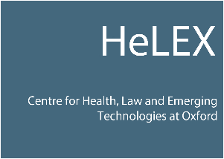

Opportunity to get involved with Artificial Intelligence in Health Research as an
Involvement Panel Member!

Could you help us to improve the research that we are doing into Artificial Intelligence (AI) in Healthcare? Would you like to contribute to a fun and interesting research project understanding how patients and the public understand and view AI? What impact might AI have for healthcare and society?

We need YOUR help to understand issues affecting patients and the public by partnering with us to ensure the research involves issues that matter to you.

Become a Patient and Public Involvement Panel (PPIP) Member!

We are looking for people to join our Patient and Public Involvement Panel. This work will involve you attending some workshop meetings, help review research documents, put forward your views on issues of AI in healthcare our research could investigate, and gain knowledge and understanding of AI in healthcare.

Face-to-face meetings will be held in Oxford at various times through the course of the project. The project is expected to last until December 2022.

You do not need to have any specific skills to join our research project – we are keen to work with people who have an interest in medical research and healthcare and who are able to contribute to group discussions to help make our research better.

We will reimburse reasonable travel expenses that enable you to help us with this work.

We are able to pay PPIP members an honorarium for their time given to project activities. Further information is available on request.

If you are interested in this role then please contact Nisha Shah via email: nisha.shah@law.ox.ac.uk OR Tel: 01865 287 896 who will answer any questions you may have and can send you further information and an application form.

The AI team looks forward to hearing from YOU!

