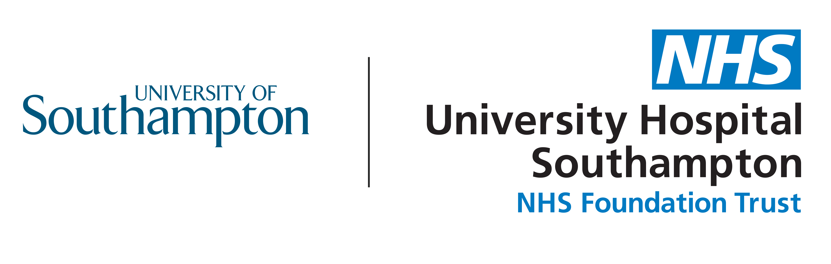

ACCORD Public Community
Introduction
You may have seen messages about the importance of research to find treatments for COVID-19 patients. Clinical trials are how we find out the effectiveness (how well treatments works) and the safety of new treatments and drugs. A lot of preparatory work goes into getting these trials set up, and this can take months.

The ACCORD platform study is one of the ways that the research community is shortening the time it can take to test new treatments.

Despite the fast pace of research, it remains important that patients, carers and the public have a voice in helping shape this research. The ACCORD team would like to form a community of individuals (patients, carers and the public) to provide their perspective to enhance elements of the ACCORD platform.

What is ACCORD?
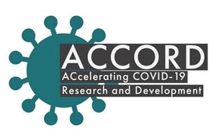
- ACCORD stands for ACcelerating COVID-19 Research & Development platform.
- It is an initiative to speed up the time it takes to set up clinical trials of potential new treatments for patients hospitalized with COVID-19. It will reduce the time to just weeks.
- Drugs which show promise in the ACCORD platform will be advanced into the next phase of testing.
- It is a national effort made possible by government, academia and industry working together.

ACCORD recently launched a website which you can view at accord-trial.org.

How can I influence?
As part of the ACCORD community you may be asked to support with how we:
- Make it easier for patients to access the new treatments and consent to take part;
- Communicate what we learn in clear and accessible ways;
- Use the data and samples collected during the trials in future research.
Due to the nature of the ACCORD platform set-up, there are certain aspects of the work that cannot be influenced or changed.

Who are we looking for?
We would like our community to reflect the diversity of people living in the UK. In particular we hope to include people who:
- Are from across England, Wales, Scotland and Northern Ireland;
- Often face additional barriers when it comes to taking part in research, such as Black, Asian, Minority Ethnic (BAME) communities, those with social and/or financial barriers, and those with disabilities;
- Are either patients, carers, and/or are from the general population.

You need to be willing to respond to requests for support with short turn arounds (as little as 24 hours) and you will need to be able to access and respond to documents sent over email. Some activities will require you to use video conferencing in order to contribute. We do not expect you to be able to contribute to every opportunity. All documentation should be treated confidentially.

How will I be supported?
The Patient and Public Involvement team at University Hospital Southampton NHS Foundation Trust will, on behalf of the ACCORD team:
- Be your point-of-contact;
- Provide you with 1:1 support as needed, such as how to set yourself up for virtual meetings;
- Organise payment for your time and expenses.

I’m interested, what next?
To register your interest in joining the ACCORD public community, or to ask any questions, please contact Caroline (public involvement lead for the study) as soon as possible.

Caroline.Barker@uhs.nhs.uk
07824 124531 (please note that I am unlikely to pick up a call without prior arrangement. Text or leave a voicemail with your information and availability and I will get back to you when I can).

We are aiming to have an introductory meeting (virtually) in the week beginning 6th July. This will be a space to discuss:
- The ACCORD platform
- The aims of the community
- Your queries and questions
- How we will work together

