Would you like to help us carry out research?

Come and join a group of people working with researchers on a study about emergency ambulance services

Not all people who call for 999 ambulance services need to be seen by a paramedic. But if access to other sources of help is reduced, these people may feel they have nowhere else to turn. Some ambulance services are linking with other health and care services to arrange the extra help these people need. This is called Case Management.
STRETCHED is a research study about how people are cared for when they need to make frequent 999 calls for an emergency ambulance. STRETCHED stands for Strategies To Manage Emergency Ambulance Telephone Callers With Sustained High Needs – An Evaluation Using Linked Data. The aim of STRETCHED is to find out whether Case Management reduces these people’s need to call 999. If it works, it will free up ambulances for other emergencies and mean callers get the right care for their needs.
The research is funded by the UK’s National Institute of Health Research. It is carried out at Swansea University. The research team includes academics, ambulance services, clinicians, managers and members of the public who have used 999 ambulance services.

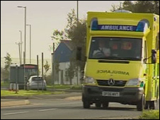 |  | 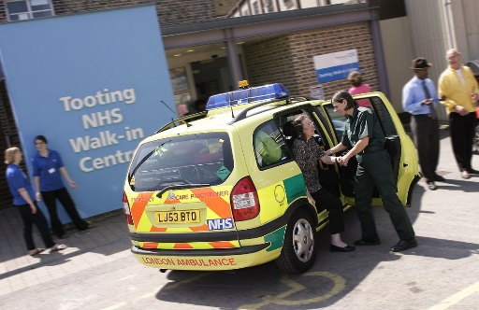
What is a Patient Panel?
A Patient Panel is a group of people whose experiences of health and care services are similar to the people we hope will take part in the STRETCHED study. Panel members will give advice to the research team. If we understand people’s experiences and viewpoints, we can make sure the research is carried out to the highest standards. It will help us ensure our information is clear, our questions are answerable and our findings are useful.

Who can be involved in the Patient Panel?
We are looking for six people who could have similar experiences to some of the people who are eligible for Case Management after calling the 999 ambulance service frequently.
- Do you have a chronic condition which could become an emergency if not well managed?
- Have you fallen several times in recent months and needed help?
- Have you made several calls to the 999 ambulance service in the past because you felt you had nowhere else to turn?
- Can your experience help us understand what it is like to need to call the 999 emergency ambulance more often?
- If so, you can help us carry out our research. Come and be an Advisor with our Patient Panel.

What will I do?
- You can join a meeting with other Patient Panel members. Or you can speak directly to a research paramedic if you prefer this to meetings.
- You can take part by telephone, WhatsApp, Skype, Facetime, or any approach that is convenient for you.
- In a typical discussion, the research paramedic will ask for comments on parts of the research plan. This could be queries such as:
  - how should we word information which is sent to patients taking part in the study
  - do the results seem logical or unexpected
  - how should we report and advertise the study findings and to whom
You can ask a friend or carer to be with you in a meeting if you want to.

How do we say thankyou?
We think people’s experience is important to help researchers. We will offer an honorarium of £20 per hour to say thank you for working with us. Payment will be through Swansea University. We will give you a claim form and show you how to fill it in.

I have a question. Who can I ask?
Local research paramedic and Rabeea’h’s details

