Eight members of the public are sought to help design Semi-Structured Interviews: Wearable activity monitors to track recovery after breast cancer treatment - Patient perspective

Role description
Eight members of the public are sought who are interested in partnering with researchers to enhance the project through taking part in critical discussions of contents and design of the study.

Summary
This project will evaluate the use of wearable activity monitors (wrist-worn sensors) which is a novel technology in breast cancer patients to monitor recovery after treatment, their experiences and activities of daily livings (ADLs) post-treatment, and how can we improve the way we provide care for breast cancer survivors who develop arm impairments. The result of this study will be implemented in developing a sensor-based scoring system for early detection of complications and creating a personalised rehabilitation programme for breast cancer survivors. The overall aim of this project is to improve care provided to breast cancer survivors.
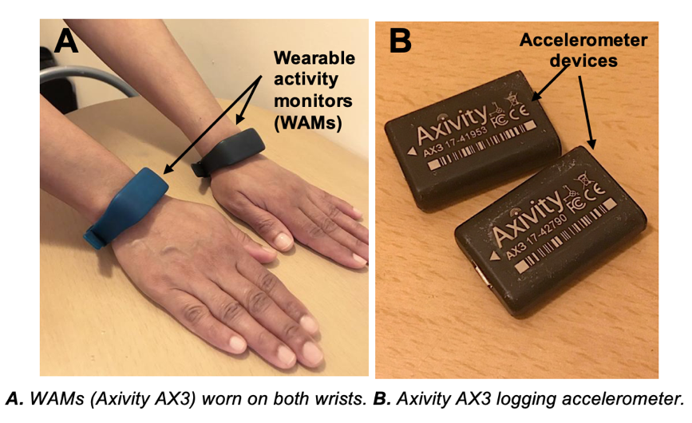
Figure 1
Background
Arm dysfunction following breast cancer treatments is characterised as a poor range of movement, pain, weakness, and swelling. For example, patients who have axillary node clearance where all the lymph nodes are removed from the armpit will experience more complications compared to patients who receive radiotherapy. These complications can persist for more than two years after treatment.

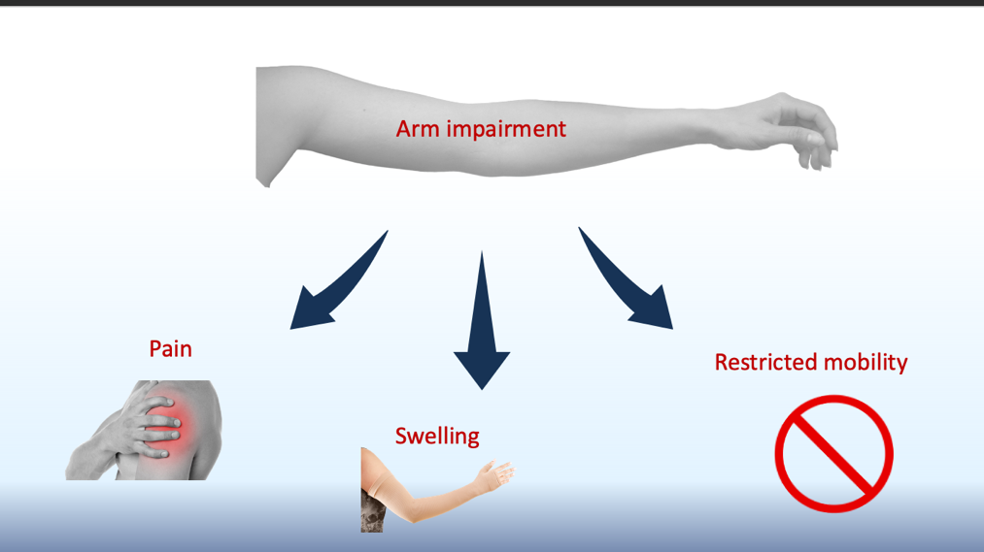

A common complication after breast cancer treatments is lymphoedema (swelling of the arm) which affects 25% of breast cancer survivors in the UK. It is estimated that the NHS spends an approximately £178 million per year on hospital admissions due to complications related to lymphoedema. McMillan Cancer Support estimated the NHS saves £100 for every £1 invested in lymphoedema treatments.

Historically, there has been inadequate monitoring of arm dysfunction after breast cancer treatments. Reasons for this are multifactorial, partly due to a lack of focus on survivorship and a lack of available treatments. However, studies have demonstrated that rehabilitation and early intervention can reduce these physical impairments.

The existing validated tools to measure arm dysfunction are mainly subjective and prone to bias. The DASH (Disability of Shoulder, Arm and Hand) questionnaire is reflective of an individual’s (potentially biased) opinion of their functionality but does not offer a comparative scale between patients. Conversely, objective measures such as arm volume (to measure lymphoedema) do not reflect functional complications. There is no continuous objective data on the profile of functional recovery from breast cancer treatments using technology such as wearable activity monitors (WAMs- figure 1) despite increasing availability. WAMs have the potential to capture a more reliable and objective measure of physical function. This could help to better define the recovery process across different treatments. Furthermore, they can potentially be used to detect early complications, and promote a feedback-enabled personalised rehabilitation programme.

Roles and responsibilities of patient and public representatives
Duties:
- Contribute to discussion of design of the project in online meeting (via Zoom or Teams) with researchers for two to four hours to discuss project details.
Areas where patient and public representatives may get involved:
- Design of a semi-structured interview questions within the project
Essential criteria for applying:
- Breast cancer survivors or relatives/carers to breast cancer patients/survivors or healthcare professionals who look after breast cancer patients or members of public who have experience with breast cancer patients
- Interest in being involved in a research project
- Confidence in giving opinions on matters and listening to others
- Able to attend online meetings

Payment
Participants will be paid an hourly rate (£25/hour) based on the Imperial recognition and remuneration policy and an additional allowance of £5 per online activity.

Support
Patient and public representatives will be:
- Buddied with the lead researcher for this project, as their main contact (below).
- Given the contact details for the patient involvement manager at the research centre for any other queries.
Further information
For further details about this project, please contact Dr Amalina Bakri at nchebakr@ic.ac.uk. The application deadline is 27th November 2020.
Semi-structured Interviews with breast cancer patients
Application Form

Researchers at Imperial College London are looking into the acceptability of using wearable activity monitors to track recovery in breast cancer patients, evaluate their experiences and activities of daily livings (ADLs) post-treatment, and how can we improve the way we provide care for breast cancer survivors who develop arm impairments. There is a huge potential to use this technology to improve healthcare and breast cancer services across the NHS. We want to ensure that if wearable activity monitors are used for this purpose, that the attitudes and concerns of patients are explored and understood.

Thank you for your interest in helping to design a semi-structured interview session on the use of wearable activity monitors for research. You will be supported by the lead researcher of this project. Reasonable expenses for your time (£25 per hour) will be covered, as per our patient and public reward and recognition policy and an additional allowance of £5 per online activity.
.

In this role, you should be able to:
- Give your valuable opinion on the development of a patient’s semi-structured interviews study
- Attend online meetings
- Listen to and work with researchers and other members of the public to discuss the research project and co-create the patient’s interview questions.

The research is being performed by researchers at the Department of Surgery & Cancer at Imperial College London.

There are eight places available in total. If you would like to apply to join, please fill out this application form and return by email to Dr Amalina Bakri (nchebakr@ic.ac.uk) by 5pm on 27th November 2020.

About you

Please complete the information below. Please type your answers in the boxes. If you need any help, please contact Dr Amalina Bakri (nchebakr@ic.ac.uk). The information you provide will be kept securely by the project team and not shared with any third parties.

Are you eligible to work in the UK? YES / NO (delete / circle one)

Are you available week commencing 30th November for a 2-4 hour online meeting? YES / NO

If you have answered ‘NO’ to either of the questions above, unfortunately, you cannot apply for this opportunity.

Full name: |  | Email:
 |  | Contact numbers: | Landline:  Mobile:
Town:
Gender (optional): |  | Age (optional): |  | Ethnicity (optional):
We are only asking you about this information so that we can be mindful about the diversity of the people applying to the group, to help ensure we are representing a broad range of voices.

Please tell us why you would like to help us with this project?

Please tell us about any relevant skills/experience/knowledge that you could bring to this project. This could include being involved in research projects e.g. sitting on study research steering groups, writing questionnaires or knowledge of novel health technologies and health record data etc

Is there anything else that you would like to tell us?

Would you like to join the Patient Safety Translational Research Centre secure mailing list, and keep informed about other opportunities? YES / NO (delete / circle one)

Next steps

Thank you for your application. Amalina will be in touch to let you know if you have been offered a place on the group by 29th November 2020
Privacy Notice
By submitting this form you are consenting to your personal data to be safely stored on an Imperial College secure server located within the UK. Access to this information is limited to the by staff involved with this project from the Institute of Global Health Innovation.
How long do we keep your data?
- We keep your details (name, contact details) for a maximum of 7 years or until you ask us to delete them.
What are your rights?
- If at any point you believe the information about you which we process is incorrect you may request to see this information and even have it corrected or deleted. If you wish to raise a complaint on how we have handled your personal data, you can contact our Data Protection Officer (see link for current post holder details) who will investigate the matter.
- If you are not satisfied with our response or believe we are not processing your personal data in accordance with the law you are entitled to complain to the Information Commissioner’s Office (ICO) (link).

