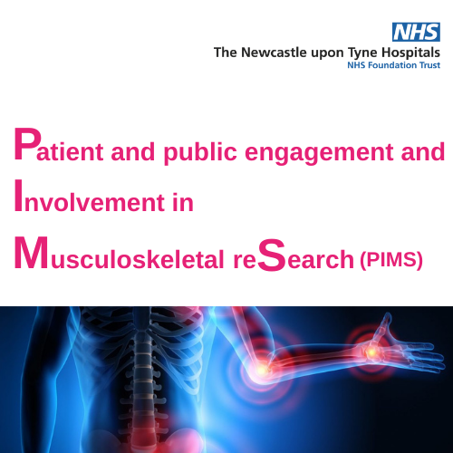
What is PIMS?
PIMS is a group for adults with an interest in musculoskeletal care who would like to learn about the research being done and make it better. Whether you are a patient, carer, friend, relative or a member of the public, everyone is welcome! You don’t have to be an expert, just have experience of a musculoskeletal condition.
What happens?
- There are lots of different ways to get involved like receiving a newsletter, telling us what you think of posters like this one, helping us to decide what research should be done, attending meetings, looking at research proposals, helping students achieve their PhD… how much you get involved is really up to you. You don’t need to have any experience just enthusiasm and a willingness to share ideas.
- We have meetings in January, April, July and October, at either the Freeman Hospital or remotely. During meetings, there will be discussions with researchers about their projects. Researchers rely on people like you to help them – make sure their ideas make sense, that their plans will work and telling them if their projects are a good idea or if they’ve missed out something important!
Often people feel that using their experience of a musculoskeletal condition to help others can be very rewarding.

Interested and want to learn more?
Scan this QR code on your smart phone camera to see our website!

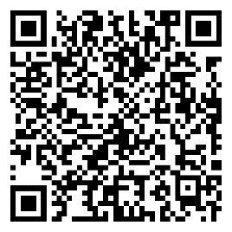
Scan this QR code on your smartphone camera to join our mailing list!
(https://www.newcastlebrc.nihr.ac.uk/patients-carers-public/pims) (NUTH.PIMS@NHS.net)

You can also contact us by phone on: 0191 283 7753 or post at: PIMS Rheumatology Clinical Research team, Room 49 Level 1 Education centre, Freeman Hospital, Newcastle upon Tyne, NE7 7DN

