# [NIHR Logo](https://www.nihr.ac.uk/)

***Help to design research to explore the best way of supporting people to stay active***

***(The AGILitY Study)***

We want to find out the best way to support people to stay active. We are doing this by exploring whether an NHS walking app can enable people to walk more, feel stronger and healthier. We need members of the public to help us design and develop this research.

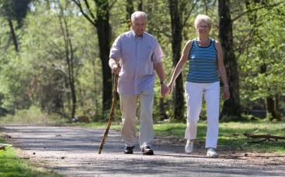

It’s important, for health and wellbeing, to stay active as we get older. Being more active and less sedentary can reduce the risk of diseases like heart disease, diabetes and cancers.

You can help by joining our Patient and Public (PPI) group, reviewing documents and giving your views on how to recruit and retain older adults into the study.

*We want to speak to older adults (over 60) from* ***all backgrounds****, particularly from diverse minority groups. You do not need any specific experience or qualifications. Just an interest in being active and a willingness to share your thoughts.*

**Join us to influence important research and to make sure patient voices are heard**

**About The AGILitY Study**

* We are testing whether an NHS walking app helps people walk more, feel healthier, and stay active.
* The AGiLITY study will compare a three-month walking app programme, with a leaflet about being active
* This is a small trial to check everything works before a larger study.
* The study is organised by the University of Cambridge and funded by the National Institute for Health Research (NIHR).

**What is involved**

Quarterly online meetings over 18 months

**8 x 1 hour meetings**

**Payment £25 per hour**

Interested in getting involved?

Contact Dr Dharani Yerrakalva [dy255@cam.ac.uk](mailto:dy255@cam.ac.uk) to register your interest